Prepare and submit the JSONL file for fine tuning.

Extract the files
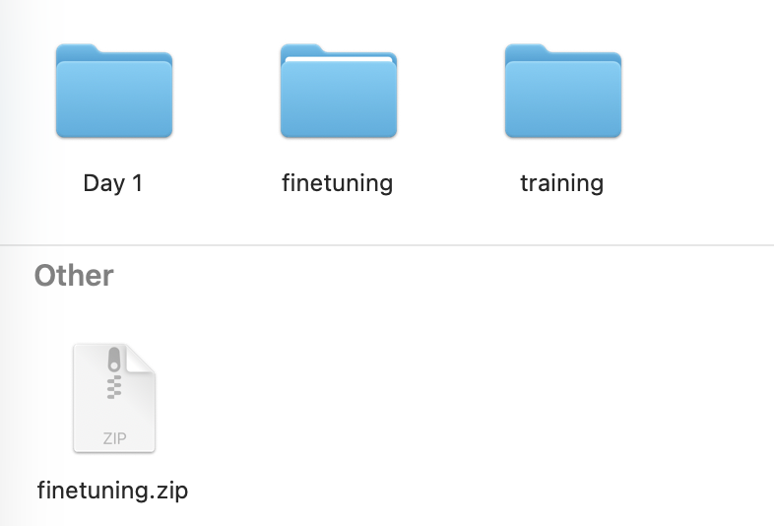

Import in VsCode

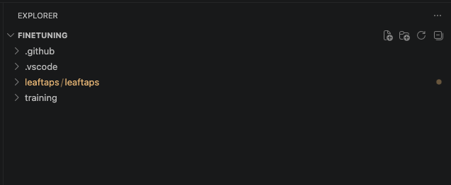

Set the Input and Output in TrainingDataConverter.java file
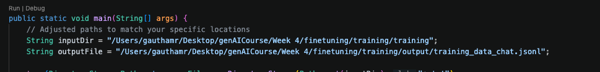
Execute the Java main program
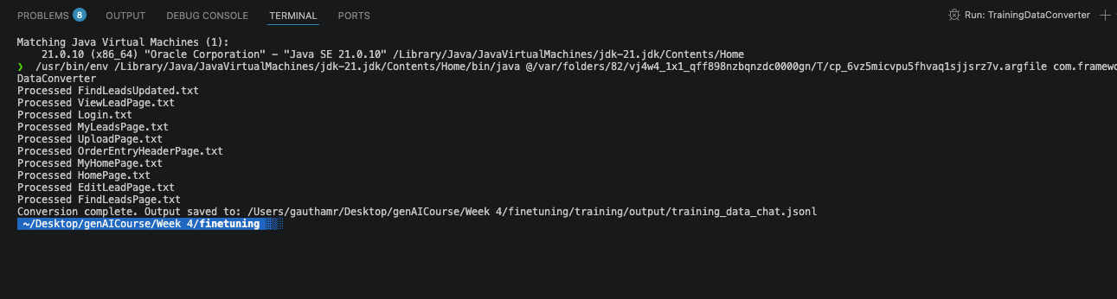
training_data_chat.jsonl is generated
